Starting Thursday
Oct 24th, 6:00 p.m.
NEW ACA MEETING

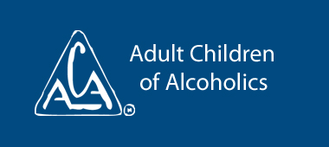
Open to all ACA’s, Steps, Open Topic, Discussion and Speaker Meeting
Oct 24th meeting – What is ACA….. Will introduce meeting format, open service positions/descriptions, and Business Meeting/Election dates
Oct 31st meeting – Sign up for service positions, pass calendar around for sign up, start phone list, Q & A
Nov 7th – Elections / Step 1
Join us as we start A Gift of Hope at New Hope Alano!
7550 Bass Lake Road
New Hope, MN 55428
Phone: 612-537-7151

